**Assignment -2**

Python Programming

|  |  |
| --- | --- |
| Assignment Date | 24 September 2022 |
| Student Name | Mr. Udhayanithi S |
| Student Roll Number | 923819104054 |
| Maximum Marks | 10 Marks |

**Question-1:**

Build a python code, Assume u get temperature and humidity values (generated with random function to a variable) and write a condition to continuously detect alarm in case of high temperature.

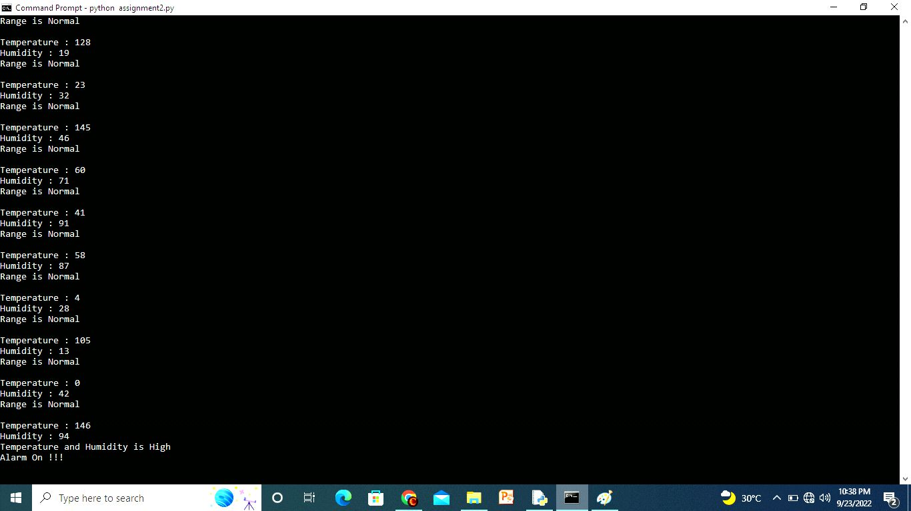**Solution:**

|  |  |
| --- | --- |
|  | import random  import time  while True:  Temperature = random.randint(0,150)  Humidity = random.randint(0,100)    if Temperature > 100 and Humidity > 80:  print("Temperature : " + str(Temperature))  print("Humidity : " + str(Humidity))  print("Temperature and Humidity is High")  print("Alarm On !!!")  print(" ")  time.sleep(2)  else:  print("Temperature : " + str(Temperature))  print("Humidity : " + str(Humidity))  print("Range is Normal")  print(" ") |